Case Study 1

You must perform below operations using Git Flow

**1.Create a Repository**

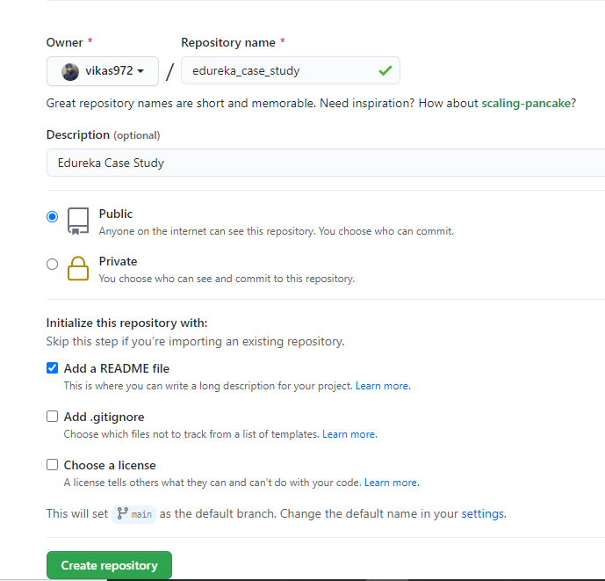

2.Add one command interface commit & push (Develop Branch).

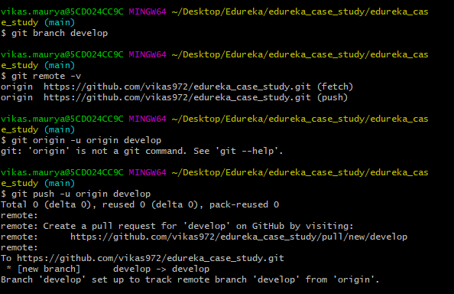

3.Create Feature Branch 112

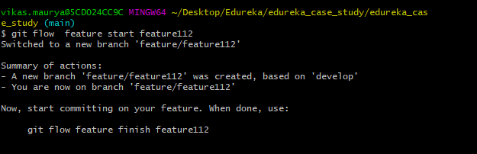

4.Add implementation commit & push

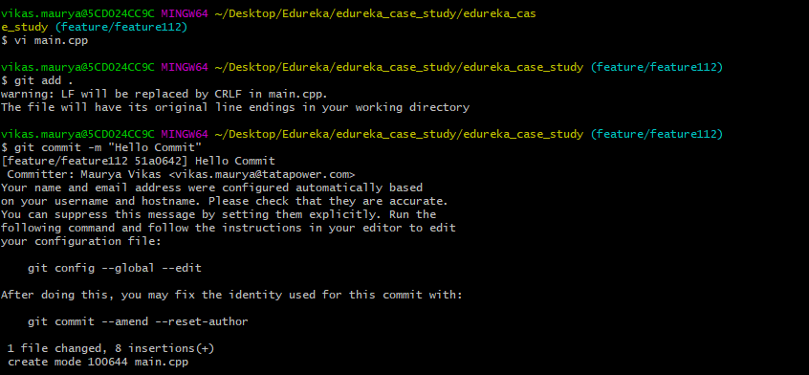

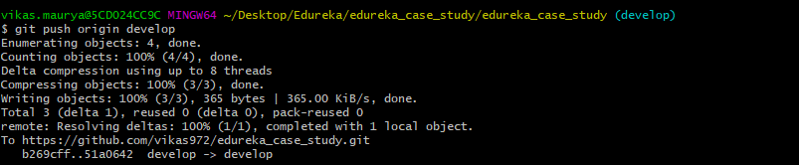

5.Merge changes in Develop branch

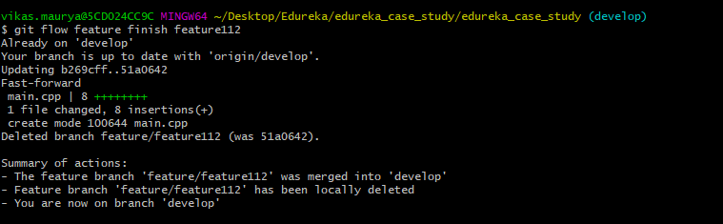

6.Create Feature Branch 113

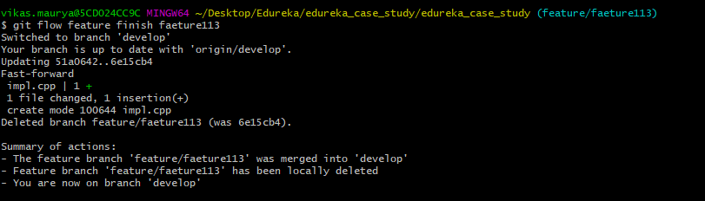

7.Add implementation commit & push



8.Merge changes in Develop branch

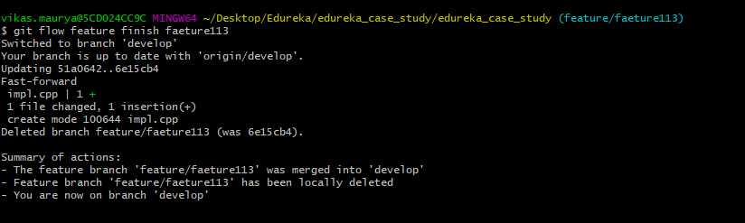

9.Create release Branch and Push

